

[Date]
[Company name]
[Company address]

All SQL Queries with Output

--KPI
--1.Total Revenue
SELECT SUM(total_price) AS Total_Revenue
FROM pizza_sales;

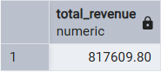

--2.Total Orders
SELECT COUNT(DISTINCT order_id) AS Total_Orders
FROM pizza_sales;

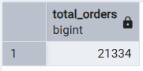

--3.Average Order Value
SELECT CAST(CAST(SUM(total_price) AS DECIMAL(10,2))/
CAST(COUNT(DISTINCT order_id) AS DECIMAL(10,2)) AS DECIMAL(10,2)) AS Avg_Order_Value
FROM pizza_sales;

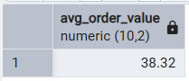

--4. Total Pizzas Sold

SELECT SUM(quantity) AS Total_Pizza_Sold
FROM pizza_sales;

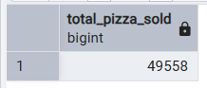

--5. Average Pizzas Per Order
SELECT CAST(CAST(SUM(quantity) AS DECIMAL(10,2))/
CAST(COUNT(DISTINCT order_id) AS DECIMAL(10,2)) AS DECIMAL(10,2)) AS Avg_Pizza_per_Order
FROM pizza_sales;

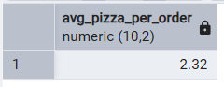

SELECT * FROM pizza_sales;

--Analysis
--1.Monthly Trend for Total Revenue
SELECT TO_CHAR(order_date, 'Month') AS Month, SUM(total_price) AS Total_Revenue
FROM pizza_sales
GROUP BY TO_CHAR(order_date, 'Month')
ORDER BY Total_Revenue DESC;

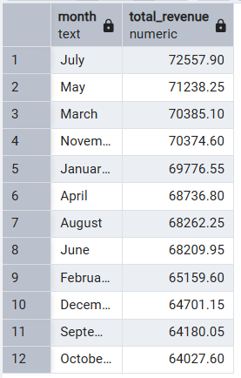

--2.Daily Trend for Total Orders

SELECT TO_CHAR(order_date, 'Day') AS Day, COUNT(DISTINCT order_id) AS Total_Orders
FROM pizza_sales
GROUP BY TO_CHAR(order_date, 'Day')
ORDER BY Total_Orders DESC;

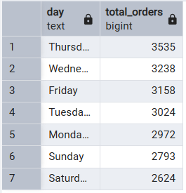

--3.Percentage of Sales by Pizza Category

SELECT pizza_category, SUM(total_price) AS Total_Revenue, CAST(CAST(SUM(total_price) AS DECIMAL(10,2))*100/
CAST((SELECT SUM(total_price) FROM pizza_sales) AS DECIMAL(10,2)) AS DECIMAL(10,2)) AS Revenue_PCT
FROM pizza_sales
GROUP BY pizza_category;

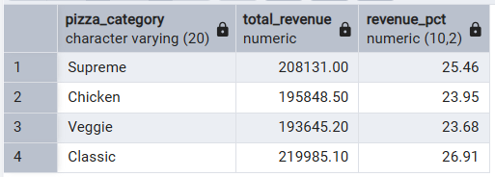

--4.Percentage of Sales by Pizza Size

SELECT pizza_size, SUM(total_price) AS Total_Revenue, CAST(CAST(SUM(total_price) AS DECIMAL(10,2))*100/
CAST((SELECT SUM(total_price) FROM pizza_sales) AS DECIMAL(10,2)) AS DECIMAL(10,2)) AS Revenue_PCT
FROM pizza_sales
GROUP BY pizza_size;

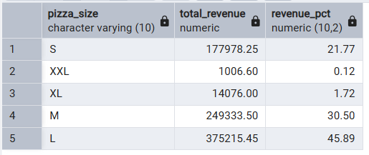

SELECT * FROM pizza_sales;

--5. Total Pizzas Sold by Pizza Size
SELECT pizza_size, SUM(quantity) AS Total_pizza_Sold
FROM pizza_sales
GROUP BY pizza_size;

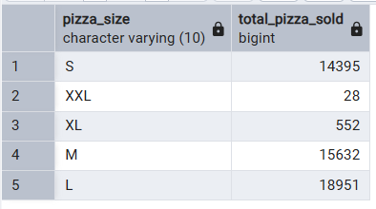

--6. Total Pizzas Sold by Pizza Category
SELECT pizza_category, SUM(quantity) AS Total_pizza_Sold
FROM pizza_sales
GROUP BY pizza_category;
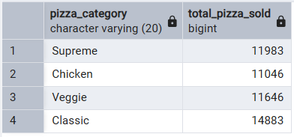

--Top & Bottom Analysis

--1.Top 5 Pizza by Revenue
SELECT pizza_name, SUM(total_price) AS Total_Revenue
FROM pizza_sales
GROUP BY pizza_name
ORDER BY Total_Revenue DESC
LIMIT 5;

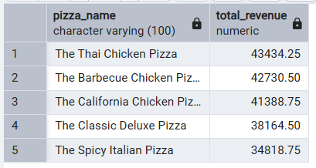

--2.Bottom 5 Pizza by Revenue
SELECT pizza_name, SUM(total_price) AS Total_Revenue
FROM pizza_sales
GROUP BY pizza_name
ORDER BY Total_Revenue
LIMIT 5;

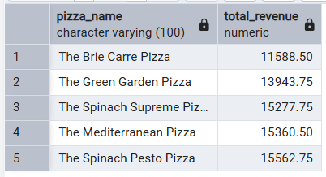

--3.Top 5 Pizzas by Orders

SELECT pizza_name, COUNT(DISTINCT order_id) AS Total_Orders
FROM pizza_sales
GROUP BY pizza_name
ORDER BY Total_Orders DESC
LIMIT 5;

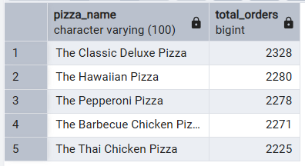

--4.Bottom 5 Pizzas by Orders
SELECT pizza_name, COUNT(DISTINCT order_id) AS Total_Orders
FROM pizza_sales
GROUP BY pizza_name
ORDER BY Total_Orders
LIMIT 5;

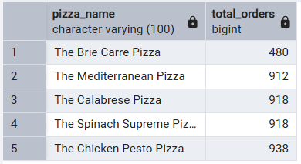

--5.Top 5 Pizzas by Quantity Sold

SELECT pizza_name, SUM(quantity) AS Total_Quantity_Sold
FROM pizza_sales
GROUP BY pizza_name
ORDER BY Total_Quantity_Sold DESC
LIMIT 5;

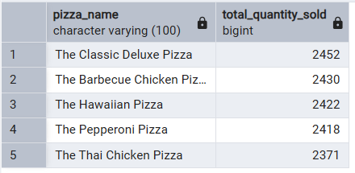

--6.Bottom 5 Pizzas by Quantity Sold

SELECT pizza_name, SUM(quantity) AS Total_Quantity_Sold
FROM pizza_sales
GROUP BY pizza_name
ORDER BY Total_Quantity_Sold
LIMIT 5;

